Capstone Project Report: Building a Secure Small Network

BY: Suleiman Lukman

luqsule@gmail.com

Introduction
Modern organizations rely heavily on computer networks to support daily operations. However, these networks are often targeted by attackers seeking to exploit weak configurations, open ports, or poor access controls. This project focuses on the design and implementation of a secure small network, with emphasis on understanding common attack techniques and applying basic security controls to mitigate them.
The project simulates a small office network environment and demonstrates how security measures such as firewalls, network segmentation, port hardening, and traffic monitoring can be used to protect systems and data from unauthorized access and malicious activities.

Project Objectives
- Design a basic but secure network layout suitable for a small office environment
- Identify common network threats and vulnerabilities
- Implement fundamental network security controls
- Test the security of the network using standard security tools
- Demonstrate understanding of how defensive controls prevent or detect attacks

Scope of the Project
The scope of this project is limited to a simulated small network environment consisting of essential network components. The network includes a router, firewall, internet connection, server, ids/ips, splunk, workstations,gsm,laptops,switches,website,printer,scanner etc.
Tools such as Nmap and Wireshark were used to analyze network behavior and identify vulnerabilities.

Network Design and Architecture
The network was designed to represent a simple office setup connected to the internet.

Network Components
• Internet Connection:
Provides access to external networks and online services.
• Router:
Directs traffic between the internal network and the internet.
• Firewall:
Filters network traffic by allowing or blocking connections based on security rules.
• Server:
Stores data and provides services such as file sharing, applications, or websites.
• Workstation:
Used by users to perform daily tasks and access network resources.
• IoT Device:
Connects smart devices (e.g., cameras, sensors) to the network, often with limited security features.
• Segmented Zones (Office Network & Guest Network):
Separate network areas to limit access and reduce the spread of attacks.
• SIEM and IDS/IPS Tools:
Monitor network activity, detect suspicious behavior, and generate security alerts.
• Firewall Manager:
Used to configure, monitor, and manage firewall rules and security policies.
• Website:
Provides online access to services or information hosted on the server.
• Switches:
Connect multiple devices within the same network and forward data efficiently.
• Printers and Scanners:
Allow users to print and scan documents over the network.
• Phones:
Enable voice communication and may connect to the network for internet

Methodolgy
A network diagram was created using the diagramming tool draw.io to visually present device connections, security boundaries, and traffic flow. The firewall is positioned between the internal network and the internet to enforce security rules and control access.
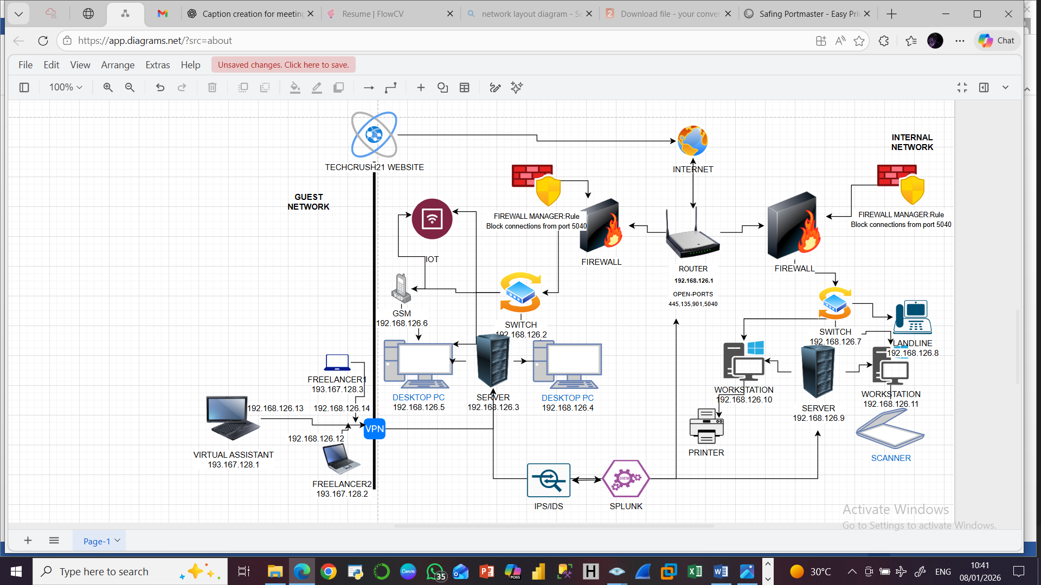

Implemented Network Security Controls
The following security controls were implemented to protect the network:

Firewall Rules;
Firewall rules were configured to;
• Block unauthorized and unknown ports; traffic through port 5040 was denied after Nmap scans identified it as unknown and potentially suspicious.
• Implement ICMP (ping) rate limiting to reduce the risk of network reconnaissance and denial-of-service attempts.
• Enable security alerts and automated responses for repeated failed access attempts, including blocking IP addresses after three consecutive failed login attempts.
Port Scanning and Hardening
Nmap was used to scan the network and identify open ports on connected devices. Based on the scan results; ports 445, 135, 5040,902,912,139 etc were found to be open.

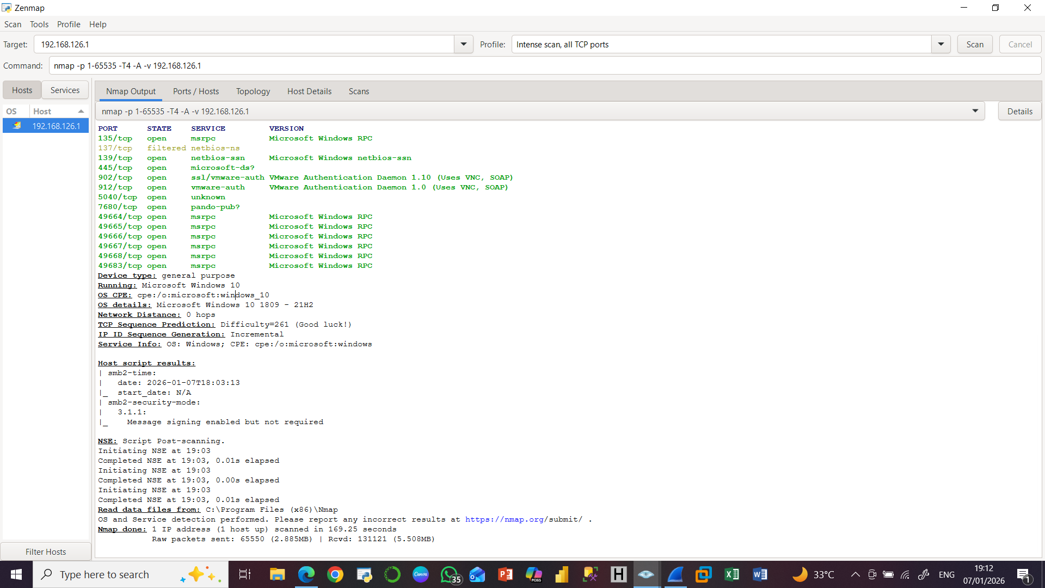

Network Traffic Analysis (Wireshark)
Wireshark was used to capture and analyze TCP network traffic, including the identification of source and destination IP addresses. This analysis provided visibility into how data flows across the network, enabled verification of legitimate connections, and supported the detection of suspicious or unexpected traffic patterns.
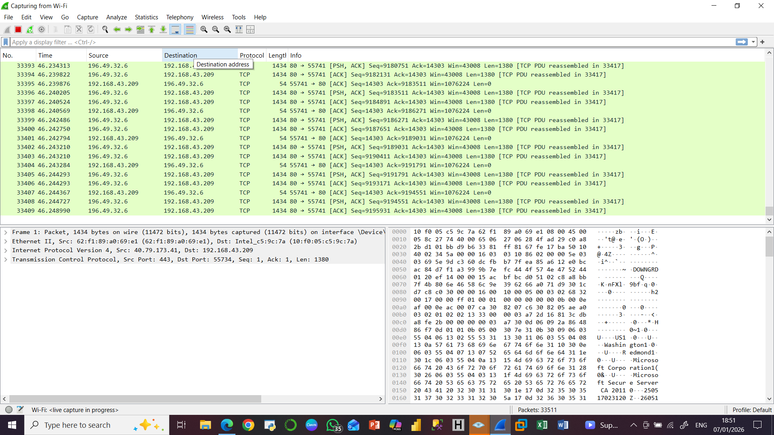

Password and Access Control
Strong passwords were configured on network devices and systems. User access was restricted based on roles to ensure that only authorized individuals could access sensitive systems or settings.

Network Segmentation
The network was segmented into internal network and guest network. Connections from the guest network to the internal network server were made through vpn.

Simulated Threat and Response

Threat Scenario
Attackers commonly use port scanning to:
- Identify open ports
- Discover running services
- Locate potential entry points

Attack Simulation
Using Nmap, a scan was performed to simulate how an attacker might probe the router in our network for exposed services. The scan showed a number of open ports which can serve as attack routes for attackers.
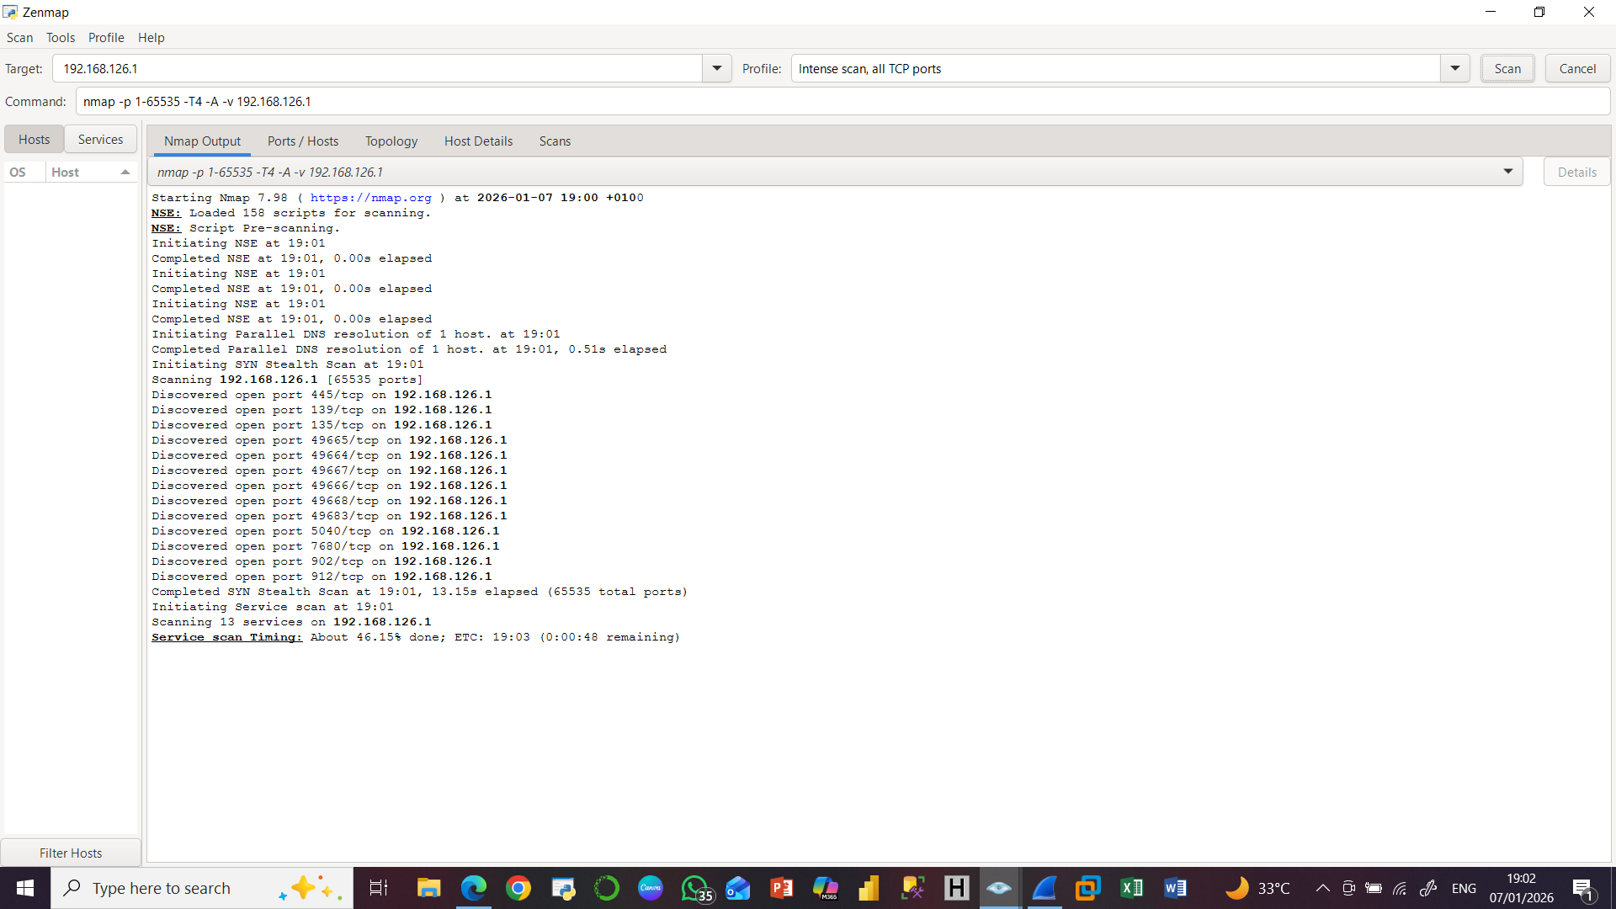

Response and Mitigation

Firewall rules were set to;
• Block unknown or unused ports
• Allow only necessary services
• Log blocked connection attempts

Port 5040 was found to be suspicious and was blocked.

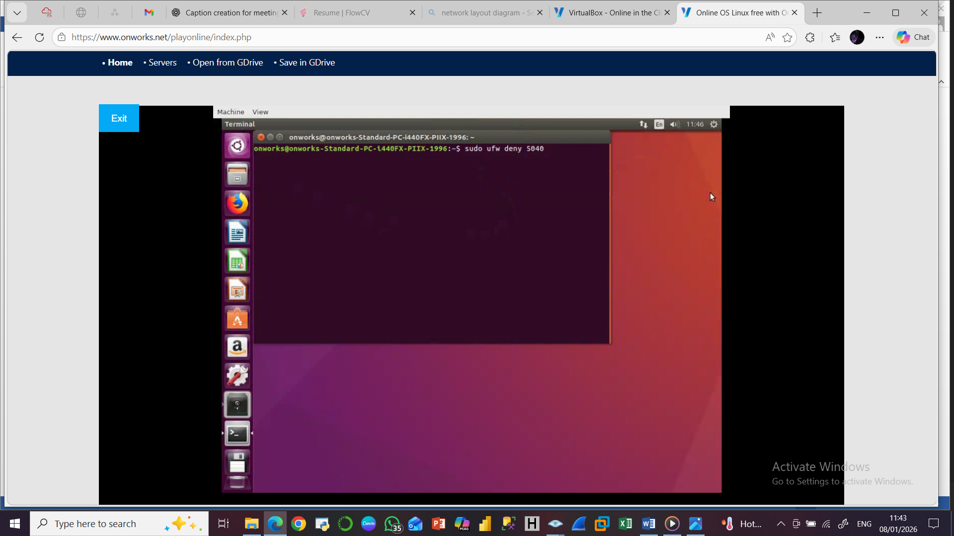

CONCLUSION
A port-scanning attack was simulated using Nmap to mimic common attacker reconnaissance techniques. Initial scans revealed exposed ports on the target system. After implementing firewall rules and port hardening measures, subsequent scans showed that unauthorized ports were filtered or blocked. Firewall logs confirmed the detection and logging of scanning attempts, demonstrating the effectiveness of the implemented controls in mitigating reconnaissance activities.

REFERENCES
Combs, G. (2023).
Wireshark User’s Guide.
Nmap Project. (2024).
Nmap Reference Guide.
National Institute of Standards and Technology (NIST). (2012).
Computer Security Incident Handling Guide (SP 800-61 Rev. 2).
Kurose, J. F., & Ross, K. W. (2021).
Computer Networking: A Top-Down Approach (8th ed.). Pearson.

